***Just FlexIt. Whenever, wherever.***

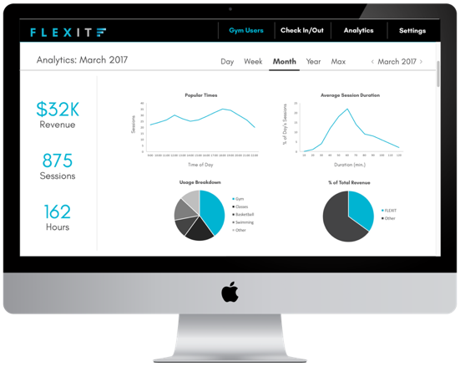*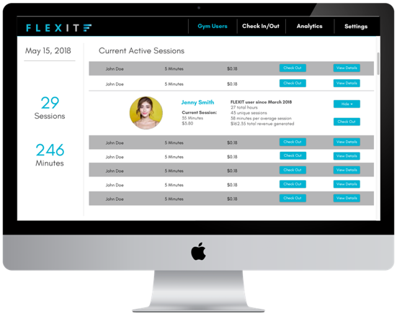FlexIt is the most flexible and convenient way for prospective new members to explore and fully experience gyms. And because there is no membership or minimum purchase required (members only pay by the minute for their club usage) the low barrier to entry will create tremendous appeal for users, driving engagement and traffic to clubs. FlexIt users will simply open the app, locate the gym they want to try, and then experience what the club has to offer..*

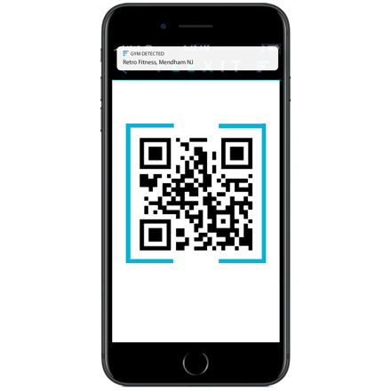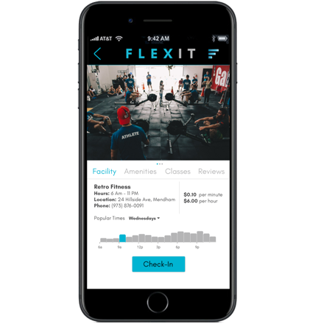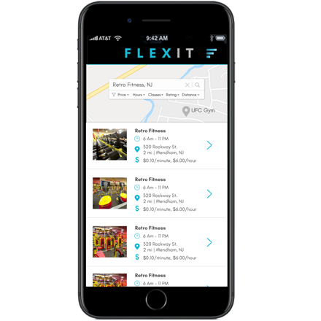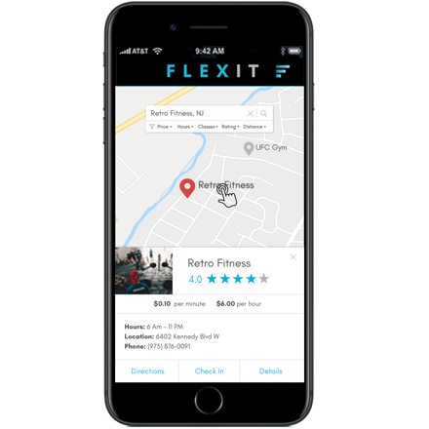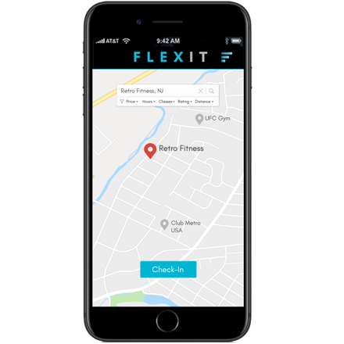

***How does FlexIt benefit your FACILITY?***

* There is absolutely no cost for the facility to offer FlexIt
* FlexIt’s platform is extremely simple to use, for both the prospective member and front desk staff and will reduce check-in overcrowding and improve process efficiency
* FlexIt’s sophisticated technology is state-of-the-art, while still being very familiar and easy to use
* **FlexIt will drive prospective member traffic to clubs (many of whom might not otherwise visit the club) and will be an important lead generation tool**
* FlexIt will generate incremental revenue (via revenue sharing for minutes used)
* FlexIt offers organic cross-promotion/marketing
  + Dedicated press releases, digital advertising, e-mail marketing, social media marketing, content marketing, influencer marketing, affiliate marketing and search engine marketing
  + This presents a unique opportunity to re-engage deactivated members, inactive members and individuals who visited but did not join the club
* **FlexIt keeps the club’s liability waiver in the app reducing club liability, promoting a paper-free environment and the waiver can be sent electronically immediately upon request**
* FlexIt will provide ample and robust date via the Club/Administrative Access Portal, including reporting data/metrics about time in facility, usage, etc.
* **FlexIt provides reliable and secure prospective member data, without reliance on paper, user submission, or front desk staff**
* Down the road
  + Dynamic pricing based on utilization
  + In app promotions - discount on membership uptick/initiation fee waived, etc.
  + Geofencing and geotargeting will allow for location-based marketing

***How does FlexIt benefit your FACILITY STAFF?***

* Simple and easy to use single-purpose hardware
* Rapid scanning of prospective members into facility, prevents slowdown at front desk
* Standard operating procedure and training provided and easily implemented
* Reliable prospective member date gathering from the app (not a paper submission)

***How does FlexIt benefit your USER?***

* Easy and flexible access to new clubs (“try before you buy”), very timely and on-trend
* No overcrowding/drama at front-desk, easy and comfortable gym access
* Familiar app interface, with multiple preference filtering options
* State-of-the-art technology
* Seamless, enjoyable experience
* Broader offering for membership options and club amenity option usage, via targeted club promotions
* Community and social platform interaction coming soon